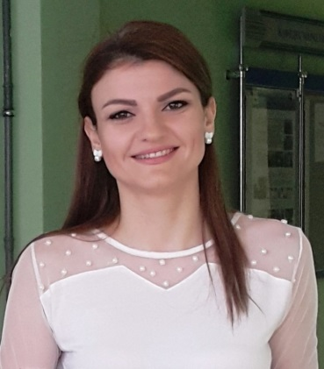

**CURRICULUM VITAE**

**Sarah Daghman**

**• Ph.D. in Economy / Marketing**

Belgorod State Technological University named after V.G. Shukhov (Russia)

Belgorod, Russia

**EDUCATION:**

**CONFERENCES, COURSES & WORKSHOPS**

Mohammad has gained a lot of experience from 9 conferences, 7 courses and 2 workshops, that were attended in the period between 2008 - 2019 in Russia, Syria and Lebanon. In addition to that, he participated in 3 scientific festivals and won first place in the one which was held in Russia in 2016. He also won a cup in a competition named, "Young Innovators BSTU named after V.G. Shukhov" in Russia 2019.

2016 – 2019

**• Master in Strategic Management**

Belgorod State Technological University named after V.G. Shukhov ((Russia)

Belgorod, Russia

2014 – 2016

**• Master of Business Administration (MBA)**

Syrian Virtual university

Damascus, Syria

2010 – 2012

**~PERSONAL DETAILS ~**

**- Nationality:** Syrian/British (English).

- **Residence:** Russia, Belgorod.

- **Date of Birth:** 06. 10. 1987

- **Marital Status:** Married.

- **Hobbies:** Swimming, playing the piano and listening to music.

**• Bachelor in Business and Economics**

Tishreen University, Faculty of business,

Lattakia, Syria

(I was one of the top 3 students throughout the four academic years of university).

2005 - 2009

**COURSES &**

**EXPERIENCES:**

**Freelancer Translator.**

2020 2019 **-** 2020

**\\\\**

**Lecturer in "Marketing"** - Belgorod State Technological University named after V.G. Shukhov / Institute of Economics and Management/Marketing department  
**Lecturer in "Tourism marketing"** – Tartous University/Tourism faculty.  
**Customer service** - Cham Capital Brokerage company (Financial advisory and services).  
**Document Controller MAG** (Maksoud Architectural Group) (IBN HANI BAY RESORT PROJECT) owned by QATARI DIAR COMPANY.

2016 - 2020

2012 - 2013

2011 - 2012

2009 - 2011

**MEMBERSHIP:**

**~ CONTACT ~**

 Russia / Belgorod

**🕽** RUS: +79611718796

**🖂** sarahdaghman87@gmail.com

**Premium Member, a management contributor at 12manage - The executive fast track** (a social enterprise that makes organizational and management know-how available globally).

Main responsibilities:

* Summarizing interesting management articles, models, ideas, etc. for inclusion on 12manage.
* Participating and sharing ideas with a community of managers, specialists and academics about management.

**RESEARCHES**

* Nonfinancial disclosures as a marketing and governance instrument for tourism organizations. (English)
* Concept of corporate social responsibility (CSR) and marketing as factors of the sustainable development of tourism. (Russian)
* Conceptual approaches to sustainable tourism through the use of integrated marketing methods. (Russian)
* Comparative characteristics of marketing analysis methods of the tourism organizations environment. (Russian)

**& STUDIES:**

**LANGUAGES & COMPUTER SKILLS**

**Α Languages:**

- English/Arabic: Mother tongue.

- Russian:

Reading skills: Excellent

Writing skills: Excellent

Verbal skills: Excellent

🖳 **Computer Skills:**

- Hold the International computer driving license (ICDL);

- Hold the certificate of Al Ameen Accounting software;

- Search and browse the internet effectively.

2019



* Integrated marketing methods for the development of regional tourism as a factor in increasing the socio-ecological and economic stability of the region. (Russian)
* Analysis of the relationship between tourism and the sustainable development of socio-economic systems. (Russian)
* The role of integrated marketing communications (IMC) in promoting travel services. (English)
* Methodological problems of modern marketing research in the field of tourism. (Russian)
* The role of the local community in tourism development.
* Features of consumer behavior of tourism services.

2018

* Social Media as a Tool for Tourism Marketing. (Russian)
* The role of tourism marketing in developing the tourism sector. (Russian)
* The impact of tourism on economic growth. (Russian)
* Tourism as a subject of socio-philosophical analysis. (Russian)
* The role of tourism in strengthening international economic relations. (Russian)
* Tourism development as an approach to strengthening the competitiveness of the region. (Russian)

2017

* Development of a market strategy for the organization in modern conditions. (Russian)
* Understanding Customer behavior. (Russian)
* The main functions of organizational culture. (Russian)

**SOCIAL ACTIVITIES**

* Participating in fundraising events (participated in the marathon for Autism).
* Participation in a number of activities carried out by the "Syrian non-governmental organization for exploration and documentation of the nature in Syria".
* Many undocumented social and environmental activities in Syria and Russia such as cleaning streets, running, planting to save our planet and supporting people ... etc.

2016

* Marketing mix in tourism. (Russian)

2015

* Communication
* Logical reasoning
* Critical thinking
* Patience
* Teamwork
* Client service
* Analytical ability
* Creativity
* Time management

**SKILLS**