Heba ABDELKAREEM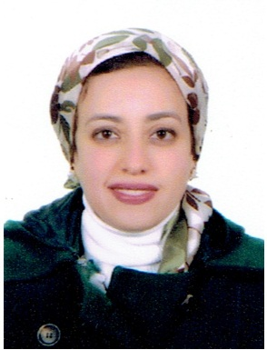
HELIOPOLIS CAIRO
ELTAYEB_HEBA@YAHOO.COM
01006613759 - 01277092179
Professional summary
Arabic French translator and the reverse
English French translator and the reverse
Skills
- Active listening
- Customer service
- Critical thinking
- Computer and electronics
- Human resources
- Sales and marketing
- Speaking and writing
- Education and training
Experience
Translator Jan 2014 –present
Freelancer translator
- Listen to speakers' statements to determine meanings and to prepare translations, using electronic listening systems as necessary.
- Read written materials, such as legal documents, scientific works, or news reports, and rewrite material into specified languages.
- Educate students, parents, staff, and teachers about the roles and functions of educational interpreters.
- Adapt software and accompanying technical documents to another language and culture.
Education
DELFB2 Institue Français d’EGYPT au Caire
MBA global management 2013
ESLSCA PARIS7
Pharmacy AIN SHAMS UNIVERSITY 2006

