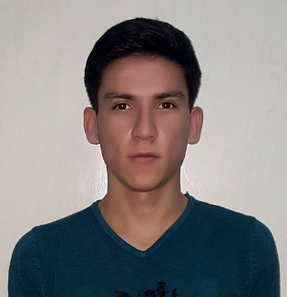
Date of birth: 20/12/1996
Full name: Tuychiev Fikrat Tuychiev
Citizenship: Republic of Uzbekistan
Occupation: Student

` Education
- 01/09/2003 – 25/05/2012 School
- 02/09/2012 – 26/06/2015, Academic Lyceum under the SamIES.
Economics
- 09/09/2015 – 06/06/2019, Management Development Institute of Singapore in Tashkent.
Finance.

Work Experience
30/05/2016 – 01/10/2016, Receptionist (Administrator)
Hotel “Lux”
Be responsible for clean environment, accepting new guests, provide good customer service, and show enthusiasm.
01/10/2016 – 01/10/2017, Translator in Upwork and Fiverr websites.

Languages
Uzbek, Tadjik, Russian, English

Interests and Activities
I like to go swimming and like playing football.
Hobbies
In my spare time I sketch various kinds of pictures
Computer Skills
I have good computers Skills, I know HTML, CSS, and a little JavaScript. I can work with Microsoft Office very well, and I have a touch-typing skill of 41WPM.

Phone: +998 (99) 872-90-27
Email: fikrat.tuychiev96@gmail.com

