PERSONAL INFORMATION | Ardit Ejupi
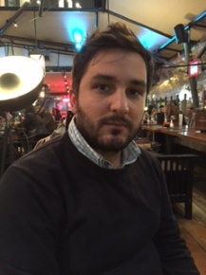 | Ulica Matije Kelemine 9, 2212 Šentilj, Slovenia
 | +386 31 206 449
 | ardit_ejupi@yahoo.com
 | Sex Male | Date of birth 18/07/1986 | Nationality Macedonian/ Albanian

JOB APPLIED FOR | Freelance translator

WORK EXPERIENCE

2005- present  2010- present | Freelance translator
 | Worked on various projects with NGO-s, private companies and government agencies in Macedonia (mostly translating paper works from Albanian/Macedonian to English and conversely)
 | Working in Slovenia as a freelance translator for Albanian, Macedonian, English and Slovenian language

EDUCATION AND TRAINING

October 2012 - present  October 2005 – January 2012  LANGUAGE SKILLS | Studying for a master degree on a law programme  University of Maribor, Maribor, Slovenia  Bachelor of law | Level VII/1 EQF
 | South East European University, Tetovo, Republic of Macedonia

Mother tongue(s) | Albanian / Macedonian
Other language(s) | UNDERSTANDING |  | SPEAKING |  | WRITING
 | Listening | Reading | Spoken interaction | Spoken production
English | C2 | C2 | C1 | C1 | C2
 | English language for specific purposes (level I, II, III, IV).
Slovenian | C2 | C2 | C2 | C2 | C2
 | Diploma na osnovni ravni (University of Ljubljana, Andragoški zavod Maribor).

Communication skills | - good communication skills gained through my experience as project manager in NGO “No Borders Center”  - Presenting multicultural projects in various seminars

Organisational / managerial skills | - Project manager

Computer skills | - Very good command of Microsoft Office™ tools

