Curriculum Vitae
SKORDILI Evlalia Vasiliki (Valia)
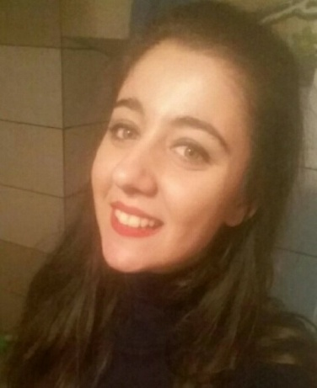
CONTACT INFORMATION
Temporary address: 13 Angelou Gialina Street, Corfu 49100, Greece
Permanent address: 132 Ierotheou Street, Patras 26224, Greece
Telephone No: 697999089, 2661551229
E-mail: valia.s@hotmail.com
Date of birth : 13/12/1992
Nationality: Greek

EDUCATION
2015- today Ionian University – Department of Foreign Languages, Translation and Interpreting – Postgraduate studies Program «Science of Translation», Corfu (redacting thesis)

2010-2015 Ionian University – Department of Foreign Languages, Translation and Interpreting (Diploma degree: 7,97/10) – Final thesis under the title «Translation and comments of children's book "Fil de fée" by Philippe Lechermeier» (Thesis degree: 10/10)

09/2013-01/2014 University of Paul Valéry Montpellier III – Department of Modern Greek Studies (compulsory semester abroad)

2007-2010 Secondary Education in the 7^{ο} Lyceum of Patras (certificate degree : 19/20)

WORK EXPERIENCE
2016 Reduction and translation of website from English into Greek

2015-today Electronic data processing and technical support in the coffee house Earth Café, Corfu

2014-2015 Secretary and translator from Greek into English and vice versa in the real estate office Aspis Real Estate, Corfu

2014 Private tutor of English (level FCE)
Private tutor of Greek to English speaker
Waitress in a coffee house

2013 Private tutor of French (elementary level)
Translation of general and technical texts from English and French into Greek and vice versa

2012 Assistant in shop with traditional goods

LANGUAGES
Greek Native speaker

English Excellent use, degree : Certificate of Proficiency in English (University of Cambridge and University of Michigan)

French Excellent use, degree : DELF B2

Russian Elementary level

Italian Elementary level

Portuguese Elementary level

COMPUTER SKILLS
- Cambridge International Diploma in IT skills at Standard Level,
including areas such as electronic communication, spreadsheets, word processing, using computer and managing files, presentations
- Database Micros Systems in hosting facilities
- Subtitle Workshop, Subedit

LECTURS AND SEMINARS
11-16/10/2010 33rd International Conference on Functional Linguistics, Ionian University, Department of Foreign Languages, Translation and Interpreting, Corfu

02-28/04/2012 Seminar on French Language and its Teaching as a Foreign Language, Laboratory of Legal, Business, Political and Technical Translation (ENOPOTEM), Ionian University, Department of Foreign Languages, Translation and Interpreting, Corfu

16-17/05/2013 Seminar on Subtitling, Ionian University, Department of Foreign Languages, Translation and Interpreting, Corfu

19/10 -16/11/2013 Project « VISIO-TRAD 2013 » («Teletranslation»), collaboration of ΕNOPOTEM and University Paul Valéry Montpellier III

21-22/11/2013 Seminar on Literature of Crete and Cyprus, and Methodology of Research, University Paul Valéry Montpellier III, France

28/04-02/05/2014 Seminar on Finnish Language, Ionian University, Department of Foreign Languages, Translation and Interpreting, Corfu

02-03/04/2016 Scientific Seminar Antonis Samarakis, Assembly of Corfu Studies, Corfu

12/11-3/12/2016 Seminar on Creative Writing «Write your fairytale», Centre of Continuing Education Andrioti, Corfu

OTHER INTERESTS
2014 – today Participation in Cultural Group of PAME (Trade Union form) - Theatrical Dancing

1998 – today Ballet, contemporary and jazz dancing

