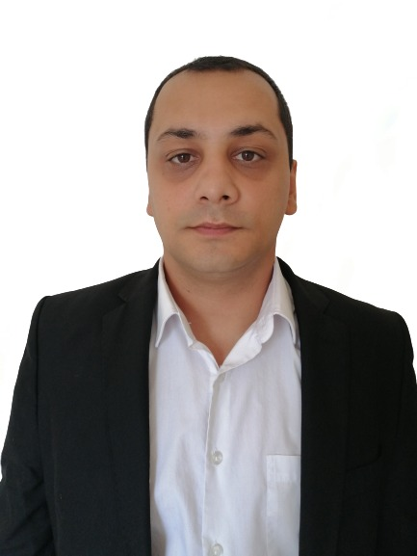 |  | TRANSLATOR  PERSONAL SUMMARY  A multi-skilled, reliable and talented translator with a proven ability to translate:  - Documents  - E-books  - Subtitles  From a source language to target language.  A quick learner who can absorb new ideas can communicate clearly and effectively with people from all social and professional backgrounds. Well mannered, articulate fully aware of diversity and multicultural issues. Flexible in the ability to adapt challenges when they rise and at the same time remaining aware of professional roles.  WORK EXPERIANCE  Freelance translator April 2010 - Present  Working freelance for translation agency providing a translation service to clients where needed. Involved converting documents and articles from one language to another and ensuring that the finished converted articles relay the intended messages clearly as possible. Also translating and editing subtitles for movies.  Have worked with various agencies and individuals from: Macedonia, Serbia, Croatia, Poland and USA.  Translating words from English to:  - Macedonian  - Serbian  - Croatian  - Bosnian  - Montegrin  And any combinations between these languages.  KEY SKILLS AND COMPETENCIES  - Excellent communication and social skills  - Able to work to tight deadlines  - Highly skilled in Word, Excel and Outlook  - Able to prioritize work

stefan panov
TRANSLATOR

CONTACT
PHONE:
+389 (0) 78/384-409

ADDRESS
Blagoj Kirkov 38,
Veles, Macedonia

EMAIL:
stefanpanov0@gmail.com

AREAS OF EXPERTISE

Translating documents
Translating e-books
Subtitling Movies
Proofreading

