9CURRICULUM VITAE

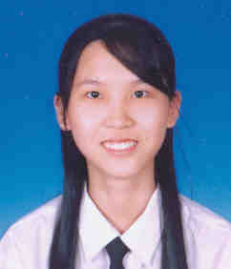
PERSONAL STATEMENT
Name : Chuah Pei San
Gender : Female
Race : Chinese
Date of Birth : 27 September 1988
Email address : summermaple927@gmail.com
Translation tools used: Prefer to translate by my own. Anyway, you can tell me if you hope me to use any translation tools.

EDUCATION
No. | Education Level | Result
1 | Undergraduate of Optometry Programme, UKM 2007/2011 | CGPA: 3.41
 | Perak Matriculation College | CGPA: 3.88
3 | SPM | 9A1 2A2 (Chinese:A1)

TRAINING/WORKING EXPERIENCE
No. | Type of Work | Date
1 | Proofreader for school magazine (Mandarin) | 2004
2 | Translation for University magazine (English to Mandarin) | 2007-2011
3 | Translation in ophthalmology field (English to Mandarin) | 2012
4 | Website translation (English to Mandarin) | 2013
5 | Translation in ophthalmology field (English to Mandarin) | 2013

