Ambitious Finnish Freelance Translator looking for  German to Finnish and  English to Finnish translations  Contact Information  Sari Ursula  sariursula.work@gmail.com  Tel: +358 50 370 5351  Add: Polvikatu 15,  15170 Lahti Finland  Business ID:  1926763-7  Education/Qualifications  Qualification name/grade  Lahti University of Applied sciences, Barchelor of Culture and Arts (Design)  4 Years  Qualification name/grade  The Finnish national Certificate of Language Proficiency (German) | 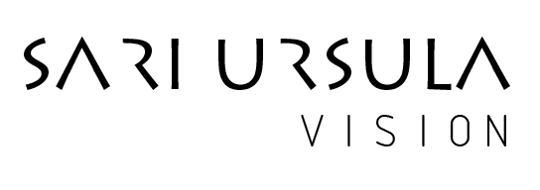  Specializes in  IT (Information Technology), Tourism & Travel, Construction / Civil Engineering, Manuals, Transport, Music, Photography, Arts,  Skills  Native Finnish  Excellent English skills  Excellent German skills  Good Spanish skills  Good Swedish skills  Microsoft Office  Photoshop  Across  Wordfast  SDL Trados Studio

