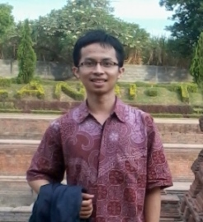
Resume
Name : Ribeh Najib Muhammad
Place, Date of Birth : Gresik, 25 September 1990
Gender : Male
Nationality : Indonesia
Present Address :
JL KH. Hasyim Asy’ari RT4 RW2 Kemangi Bungah
Gresik, Indonesia
Tel.+6285746344409
Email : ribehnajib@gmail.com
Phone : 628585746344409
-EDUCATIONAL BACKGROUND-
2012 – Present English Language and Literature Education; Surabaya State University (Master Degree)
2008 – 2012 English Education; Surabaya State University (Bachelor Degree)
-EXPERIENCES-
High school magazine writer and editor, 2007-2008.
Freelance Translator. Since 2009.
-COMPUTER SKILLS-
Operating System : Microsoft Windows.
Software : Microsoft Office, SDL Trados Studio, Google Translator Toolkit.
-LANGUAGE SKILLS-
Indonesia : Native.
English : Fluent.
-TRANSLATION EXPERTISE-
- General
- Education
- Religion
- Science
- Tourism
- Social and Humanism
- Literature & Prose
- Linguistics
- Computer

-RATE-
- Translation
English to Indonesia : 0.03 EUR / word
Indonesia to English : 0.03 EUR / word

- Proof Reading
Indonesia : 0.015 EUR / word
- Daily Output
Approximately 1.000 words / day

-Willingness to take a Test-
Yes I’m willing to voluntarily take a translation test to proof my skill.

