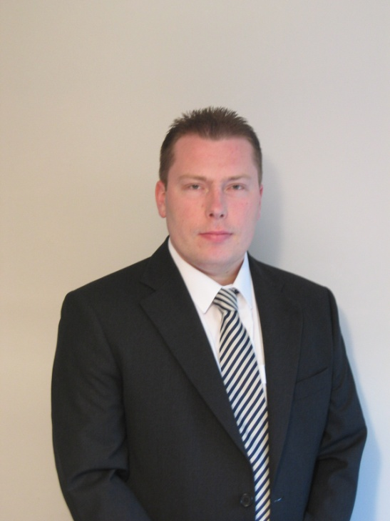

Nathan Dodd

nathan_dodd1@hotmail.com

Curriculum Vitae

Personal Information
Name Nathan Dodd

E-mail nathan_dodd1@hotmail.com

Address The Gables, Burroughs Piece Road, Sudbury, Suffolk, CO10 2PR

Telephone number 0774 5259788 (UK mobile phone)

Born on: 2 November 1971 in Billericay, Gt. Britain

Marital Status single

Education
1985 - 1988 Thurston Upper School in Thurston,
Leaving Certificate(s): GCSE

1988 - 1991 King Edward VI Upper School in Bury St. Edmunds
Leaving Certificate(s): GCE A-Level
University Study
1999 - 2003 University of Portsmouth, Portsmouth
Leaving Certificate / Grade:
BA Hons. Languages with International Trade 2.1

Current work
11/2005 - 8 years as a translator/technical writer (freelance)

General fields:
Business, finance, administration, insurance, marketing
Civil and patent law (business contracts and patent applications)

Specialist fields:
Medicine and pharmaceutics (regulatory affairs, product compliance and labelling regulations, packaging inserts, SmPCs), medical devices (approvals, risk analyses, technical manuals and operating instructions)

- Writing and updating technical documentation (in English), such as user instructions, service manuals / software manuals
- Writing and updating assembly instructions and test instructions for the manufacturing of products
- Editing and updating drawings, photos and screenshots
- Proofreading and reviewing reports, reviews and approvals
- Working alongside project managers in order to discuss change management, client requirements and deadlines

Previous work
6/2005 - 11/2005 Translator at Patent Attorneys - Schwabe, Sandmair & Marx in Munich, Germany
2003 - 2004 IT Helpline Technician at CSG / IBM in Erfurt and Leipzig, Germany
2003 Proofreader / Quality Manager 'Transperfect Translations Ltd.', London
2000 - 2001 Customer Service Advisor, 'World Duty Free Ltd.' at Gatwick Airport, London
1999 - 2001 Doorman, 'Firebird Restaurant', London
1988 - 1999 Price control clerk, Cashier, Supermarket chain 'Tesco Stores Ltd.' London
1996 - 1998 Salesman, Franchise Partner, 'Eismann' in Essex
1992 - 1996 Crew Member, McDonalds, Bury St. Edmunds and Cambridge

Work Experience
04/2002 - 09/2002 Fields: Marketing, Analyses, Research work, Client acquisition
Eurocoin AG in Schwerte, Germany

09/2001 - 11/2001 Field: Financial Services / Administration
Work experience funded under the EU programme for worker mobility
IATA in Frankfurt /M., Germany

Further Training
2004 In-House course, CSG / IBM Erfurt - Lotus Notes 6

Other
- Pecuniary damage liability insurance
- Skilled in MS Word, Powerpoint and MS Excel, Lotus Notes 5 & 6
- User level experience: SAP R/3 Inventory software,
- TRADOS Translation software (2007 and Studio 2014)
- Adobe Framemaker and Photoshop
- Working knowledge of French
- Driving licence / Flexible in terms of location

Interpersonal skills
- In my everyday work, I am relied upon to be efficient, organised, service oriented as well as capable of communicating clearly
- I am an attentive listener and I follow instructions
- I am creative and have good analytical skills
- I am dependable, committed to the work I do, loyal and respect the values of others
- I inspire trust, work conscientiously and take personal responsibility
- I am member of the Linked-in group ‘Pharma in Switzerland’

