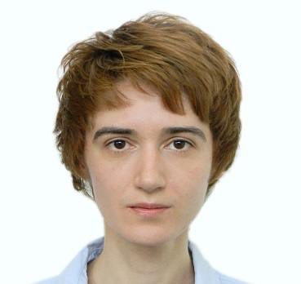
NATALIA DOLZHENKO
43 Ivan Kudria Str., Kyiv, Ukraine
Mobile: +38(096)7881483
E-mail: natalie.dolzhenko@gmail.com

PROFESSIONAL TRANSLATION AND INTERPRETING
Assiduous and detail-oriented Translator and Interpreter with a proven ability to translate complicated texts such as legal, IT and technical documents. Interpreting during business meetings. Excellent communication and presentation skills and strong knowledge of law. Excellent Ukrainian, Russian and certified proficiency in English. Core areas of interest: linguistics, law, politics, social issues, psychology.

PROFESSIONAL EXPERIENCE
January 2016 — Present
Freelance Interpreter
- Interpreting in consecutive and chuchotage modes during business meetings, in court and at the notary office, negotiations over the phone.

August 2013 — Present, ALESCO Translation Centre, Kyiv
Translator
- Translate various legal documents, such as contracts (purchase, lease, share distribution, non-disclosure, etc.), founding documents, court documents, and business letters.
- Translate documents for international organizations (Crown Agents, OECD, OHCHR, GOAL, World Bank), including reports, recommendations, technical documents, the EU directives and regulations, memoranda, letters, presentations and press releases.
- Translate media reports, subtitles, and marketing materials.
- Perform proofreading and quality assessment.

September 2012 —July 2013, Technolex Translation Studio, Kyiv
Translator
- Translated UI strings, user guides, specifications, marketing materials and other technical documents for such companies as Microsoft, Nokia, Forza, Apple.
- Used specialized translation software (CAT tools) in the production of translations and formatted documents as specified by the clients.
- Performed proof reading and quality assessment.

EDUCATION
Kyiv National Linguistic University, 2008-2012.
Degree in Languages majoring in English Translation.

Kyiv National University of Internal Affairs, 2000-2006.
Master’s Degree in Law

SPECIAL SKILLS
- Ukrainian, Russian, English — fluent.
- French (A1–A2).
- Competent computer user: MS Office, Internet, Trados, memoQ and other CAT-tools.
- Course in consecutive English translation, 24 academic hours, Simultaneous Translation School, Tris Translation Centre, 2016

PERSONAL INFORMATION
Single, no children.

