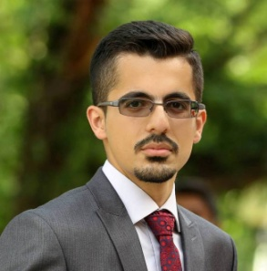
Nahro A. Mahmud
Email : nehro13579@yahoo.com
contact : 0771 156 5604
Date of birth : 16-Nov-1994

EDUCATION : Bachelor in Electrical Engineering, class 2016
University of Sulaimani - Slemani, Kurdistan, Iraq
SKILLS : Language skills Other skills
. Kurdish(fluent) . PLC programming with Codesys
. Arabic(fluent) . Arduino Microcontrollers
. English(very good) programming
. AutoCad
. Microsoft office (Word, Excel)
. Matlab
. Programming with C++
EXPERIENCE : I worked during the holidays at Qazaz Electrician Market in Slemani, for two
years and then worked with Adat Group only for gaining new Experience for
one year.
INTERESTS : During my free time in the past four years i worked as a volunteer in many
projects for the purpose of raising awareness about homeless children's lives
Projects such
1- The one shot project (Concerned about cultivating skills of children)
2- First stage Qalawa ( Funded by the American University of Iraq-Slemani,
project purpose was for providing basic education).
and other smaller projects for collecting donations.
Hobbies : playing Music, Hiking
ACHIEVEMENT & AWARDS :

1- Certificate of Completion 2 days training on WAGO PLC at Karlsruhe Institute
of Technology(KIT), Germany.
2- Certificate of Completion 2 days training about Renewable Energy
at Karlsruhe Institute of Technology(KIT), Germany.
3- Certificate of Honor for winning the "Engineering Day" competition with 1st
place, for best Engineering project under( Mechanical , Electrical )
Engineering among 7 participated Universities.
4- Certificate of Completion 15 hours training in Electrical design of Buildings.

