CURRICULUM VITAE
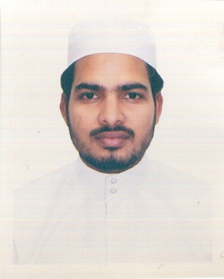

MOITHEEN P.U.
Email: muhyidheen@yahoo.com
Contact: 00973-39477189 (Bahrain)
0091-9995053484 (India )

OBJECTIVE
To achieve a solid foundation in the field of translation and to attain a respectable position in same through strive and continuous learning.

EXPERIENCE
- 9 Years experience as an Arabic Teacher.
- 5 years experience in the field of Arabic - English Translation

EDUCATIONAL QUALIFICATIONS
- S.S.L.C.
- B.A. Arabic

COMPUTER KNOWLEDGE

- MS-Word, PowerPoint

PERSONAL INORMATION

Date of Birth : 20.05.1982
Gender : Male
Marital Status : Married
Nationality : Indian
Languages Known : Arabic, English, Hindi, Urdu, Malayalam
Permanent Address : Palamoottil House
Asamannoor P.O., Nooleli
Ernakulam District, Pin: 683549
Kerala, India

