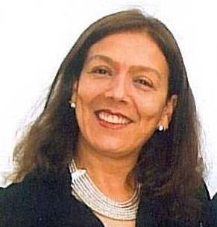

MARISOL LA HOZ VALLE
“I am passionate about languages.”

Education

Pontificia Universidad Católica del Perú
Bachelor's degree in Humanities with specialization in Linguistics and Literature

Universidad Femenina – Unifé

School of Translation and Communication Sciences (incomplete education)

Laboratorio Internazionale della Comunicazione
Scholarship awarded by Università Cattolica del Sacro Cuore in Milan and Università di Udine, sponsored by UNESCO.
Gemona del Friuli, Italy

Università per stranieri di Perugia, Italy
Italian Teaching
Scholarship awarded by the Italian government

Professional Experience

Lexitrans Perú SAC  Proofreader – Translator | 1993 – current

Editorial Bien de Salud  Copy Editor | 2015- 2017

Cross-Cultural Solutions Peru (international volunteer agency)  Spanish Tutor (Spanish as a foreign language) | 2001 – 2015

Nexuslingua SAC  Translator | 2008 - 2013

Universidad Científica del Sur – UCSUR  Language Teacher | 2009

Association of Professional Translators of Peru  Writing Teacher | 2009

BBVA – Continental  Writing Teacher | 2002 - 2007

Novalis Traducciones y Servicios Srltda.  Copy Editor, Proofreader and Translator | 1994 - 1995

Istituto Italiano di Cultura  Italian Teacher and Translator | 1987 - 1990

Colegio Antonio Raimondi  Italian Teacher | 1987

Training in Sweden

Korta vägen Program, 2018
Working in Sweden for foreigners with higher education.
By Academicum, KTH and Uppsala Universitet.
Practice at Edströmska gymnasiet in Västerâs as assistant of English courses.

Languages

Spanish - native language / SIELE International Certification – Instituto Cervantes
Italian – near native language
English – second language
Swedish - SFI – Kurs C och Babbel

IT skills
MS Office, Internet

References

Lucia Grimaldi
Project Manager – Korta vägen
luciagrimaldi@linkedin.com

María del Carmen Pizarro
Director of Lexitrans Perú SAC
mpizarro@lexitrans.net

