**PHAM TRAN HANH LINH**

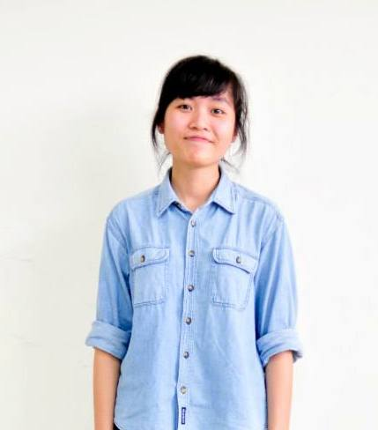

**PERSONAL DETAILS**

**Address:** 500 Thuy Khue Street, Tay Ho District, Hanoi

**Mobile:** +84 91 347 9889

**Date of birth:** 18th December, 1993

**Nationality:** Vietnam

**Gender:** Female

**Email:** [hanhlinh1993@gmail.com](mailto:hanhlinh1993@gmail.com)

**EDUCATION**

**2008 – 2011** Foreign Languages Specializing High School

**2011 – present** Faculty of Law, Vietnam National University

**WORK EXPERIENCE**

**2011 – present** Freelancer

**July 2014 – September 2014**Globalink Research Intern at University of Waterloo, Canada

**October 2014 – present** Administrator of Opportunities for Vietnamese students

(<https://www.facebook.com/opportunitiesforvnese>)

**January 2015 – April 2015** Intern at Vietnam International Law Firm (VILAF), Hanoi

**ACADEMIC ACHIEVEMENTS**

**2011** Student with the highest entrance score to Faculty of Law, Vietnam National University.

**May 2014** Second runner-up in Moot Contest 2014.

**November 2014** Recipient of Globalized Era Scholarship (GES)

**ACTIVITIES**

* **Founder and Performer of CNN Rock Club:** September 2008 to October 2010
* **Volunteer in Vietnam Museum of Ethnology:** 2009 and 2010
* **Local supporter of Volunteer For Peace Vietnam:** June 2012 to August 2012
* **Delegate in Model United Nations Hanoi 2012:**August 2012
* **Volunteer at National Hospital of Pediatrics:** October 2012 to December 2012
* **Participant of Vietnam Youth Forum 2013:** July 2013
* **Participant of Asian Students Environment Platform in Korea:** August 2013
* **Member of English Club, Faculty of Law:** October 2013 – present
* **Member of Asian Law Students’ Association:** May 2014 to September 2014
* **Volunteer in the 14th Informal ASEM Seminar on Human Rights in Hanoi:** November 2014

**SKILLS**

* Languages: English *(advanced, IELTS 7.5)*, Japanese *(basic)*
* Computer skills: Microsoft Office, Prezi, Cool Edit Pro, Adobe Audition, Proshow Producer
* Abilities: Working under pressure, working independently, group working, doing arts (singing, song-writing, playing guitar, taking photos, and making videos)