 | KHOLEES BINTI MOHD YUSUF
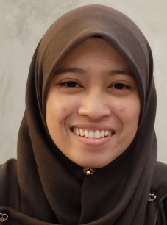 | PT 1644 TAMAN AZAM, JALAN LONG YUNUS, 15200, KOTA BHARU, KELANTAN  013-2859551  coldleast94@hotmail.com

Objectives
Active, skillful, creative and multi skill individual seeking a position as a translator that offers both a challenge and a good opportunity industrial growth.
Education

Universiti Selangor, Bestari Jaya (2015-2017)

Bachelor of Education (Honours) TESL : CGPA= 3.24
Dean’s list award on 1/17/34 : GPA= 3.5
MUET (March Session 2017)
Band 4 : 190/300

Universiti Selangor, Bestari Jaya (2012-2014)
Diploma In TESL : CGPA= 2.95
experience

SK Selayang Baru Dua (Selayang)
- Practicum Primary English Teacher
- June-September 2014

SMK Sierramas (Sg Buloh)
- Practicum Secondary English Teacher
- June-September 2017
skills
- Language: Fluency in Bahasa Melayu and English
- Communication: Comfortable writing and speaking
- Computer literacy: Proficient at MS Word, MS Powerpoint and Movie Maker
involvements
- Participant : Larian Smart OKU Awareness (6th May 2017)
- Participant : Program 2 Jam Senam Robik Sempena Hari Sukan Negara 2016 (8th October 2016)
- Actress in Macbeth : Theatre in TESL (20th April 2016)
- Participant : Bengkel Pengupayaan Komuniti – Kenali OKU (20th February 2016)
- Participant (was categorized as a first winner) : Click-click Competition (26th November 2016)
- Participant : Xplorasi Kerjaya located at UPSI (29th November 2016)
- Registration Bureau in Educational Sociology Conference at Unisel Senate Hall (20th November 2015)
- Secretary : Pertandingan Memasak Anjuran Event Management Ogos 2015 (24th October 2015)
- Participant : Sijil Rendah Silat Cekak Unisel Bestari Jaya (21st June 2014)
- Secretary : Pengakap 42KB SMKKB (2011)

