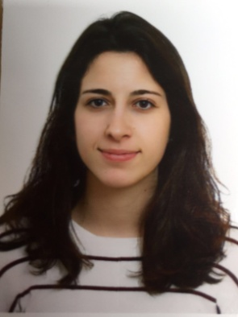
CURRICULUM VITAE
Irene Vallet Ruiz
Birthdate: 20/02/1996
Born at Cullera, Valencia (Spain)
Resident in
C/ Replà del Sant Antoni 27, Cullera 46400, Valencia
Phone number: +34 672783359
irenevalletruiz@gmail.com

Studies:
Degree in English Studies by University of Valencia (2014-2018) – Spain.

Skills and competence:

Languages: - English: Expert level, orally and written (C1 level, 2016)
- French: Medium level, orally and written (A2 level, 2012)
- Spanish: Expert level, orally and written (native).
- Catalan: Expert level, orally and written (native).

Social and
personal
skills:
- Conversational skills with children and adults in several languages.
- Ability to learn new things easily
- Great capacity to work under preassure, and easy adaptation under difficult circumstances
- Ability for multitasking and great attention capacity in critical situations.

Professional experience:

- Spanish conversation teacher in the language school “Club des Langues” in Anglet, France, in August 2018.

- English particular teacher for children between 8 and 18 years old, intermittently from 2015.

- Piano teacher in the music school “La Ruche” at Biarritz (France), with groups of children between 6 and 12 years old, from October 2018.

- Experience as waitress at “Bar Terrassa” in Cullera, (Valencia, Spain), 2017.

- Work as a volunteer in Service Civique (France) in the domains: “Cinema and citizenship” and “Fight against food waste” at Jean-Taris high school in Peyrehorade, from November 2018 to present day.

Additional education:

Translation courses at the University of Valencia, in the domain of English studies.

