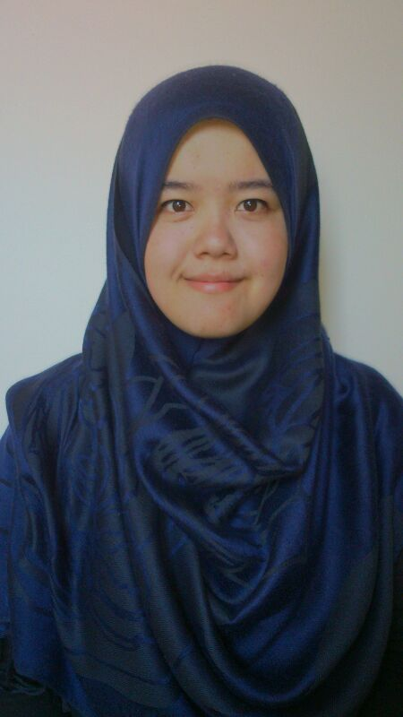

NORSHAKIREEN BINTI KHAIRUL SHAHROM

PERSONAL PARTICULARS

Name : | Norshakireen binti Khairul Shahrom
Faculty : | Faculty of Applied Science
Student ID : | 2010448462
Program : | Diploma In Science
Passport/Mycard No. : | 920301-06-5206
Telephone No. (House) | 064778231
Cell-phone : | 013-6436026
Email | lilibunga57@yahoo.com
Date of Birth | 1 March 1992
Age | 22 years old
Gender | Female
Nationality | Malaysian
Religion | Islam
Races | Malay
Address | A 94 Felda Bukit Jalor, 73200 Gemencheh, Negeri Sembilan.

ACADEMIC ACHIEVEMENT

 | Description | Grade | Year Involved
1 | Universiti Teknologi MARA, (UiTM)  Diploma In Science | 2.93 | 2010-2013
2 | Sekolah Menengah Kebangsaan Jengka 21,Pahang.  Sijil Pelajaran Malaysia (SPM) | 4A,2B,3C | 2009
3 | Sekolah Menengah Kebangsaan Jengka 21, Pahang  Penilaian Menengah Rendah | 7A, 1B | 2007

CURICULAR ACTIVITIES

 | Activity | Year Involved
1 | Latihan Intensif Bakal Komander Badan Beruniform UiTM Pahang | 2010
2 | Jambori Tahunan Komander Kesatria UiTM Malaysia | 2012
3 | Pemimpin Minggu Destini Siswa (PMDS) | 2011-2013
4 | Orienteering Peringkat IPTA & IPTS | 2012
5. | Kursus Bina Negara Asas (BTN) | 2011
6. | Kursus Tali Tinggi dan Menyelamat peringkat belia | 2011

SKILLS
 | Description | Details
1 | Computer skills | - Microsoft Words  - Microsoft point  - Microsoft Excell  - Photoscape
2 | Language | - English (Spoken=6/10, Written=8/10)  - Malay (Fluent)
3 | Personal skills | - Highly adaptable to new environments, fast leaner,quick at handling new and unfamiliar situations.  - Able to communicate with others.  - Wiling to work in shift hours and travelling.  - Recognize the value of teamwork and team spirit. Able to cooperate and work well with others.  - Committed to career and independent.  - Active and adventure person
4 | Licence | - D  - B2

WORKING EXPERIENCE

 | Company | Position | Skill | Year involved
1 | TDK Lambda , Senai | Operator | Able to work in one teams, fast learner and ability to work with active condition. | 2013-2014

