Curriculum Vitae
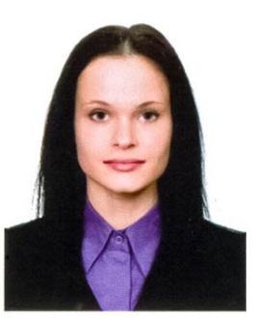
Personal Details | Inga Fedosova, 24 years old  Date of Birth: 11.03.1991  Address: 7 ap., 32/1 Dzerzhinskogo pr-kt, Novosibirsk city, Russian Federation  Tel.: 8-953-766-1955  E-mail: culpable@inbox.ru  Marital status: single  No children
Education | 2009-2013 г. Novosibirsk State Technical University,  Liberal Education Faculty,  Bachelor of International Relations (Orientalist)
Additional Education | 2015 participation in academic conference "Teaching English at schools of the XXI century", based by "Novelta";  October-December 2013 Transport Logistics, practical course, based by “Siberian centre of logistics and customs service”;  2009-2012 Spanish Language Course (Educational Centre in Novosibirsk State Technical University)  2007-2009 г. Office manager course
Professional Experience | 2014 – present, teacher of English, Foreign Language School “Unicity”  Teaching English of CEFR levels A1 - B2 in groups of students;  2013 – 2014, logistician, “Elementa” Ltd.  Translation of business correspondence and official documents from English to Russian and from Russian to English;  2013 – 2013, teacher of Japanese, Educational Centre in Novosibirsk State Technical University  Teaching Japanese in groups of students
Additional Skills | English (Advanced),  Japanese (JLPT: 3 level),  Spanish (Elementary);  Computer Skills: MS Windows 2007, Word, Excel, Photoshop, CorelDRAW, Skype, work in internet;
Personal Qualities | Fast learning capability;  High working capacity;  Polite and persuasive;  No bad habits

