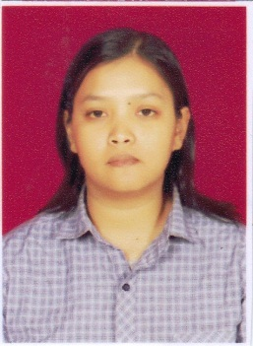
Indah Nurul Fitria
inurulf@gmail.com
62-81223-786215

Personal Statement
Computer skills include internet research for personal and business purposes, Microsoft Word, Excel, PowerPoint, and outlook, ForTheRecord, Aegisub, and Express Scribe Transcription Tool, OmegaT, ABBYY and Fluency CAT Tool. Language skills include excellent oral and written English and fluency in Bahasa Indonesia, translation for general, medical, legal, and scientific writings. Highly adaptive, open-minded, independent, responsible worker and curious and fast learner.

Career Objective
Seek the position of Translator

Key Skills
Internet Research Data Entry Translation Transcription Editing

Education
2006-2013 Bachelor of Humanities
English Literature
Faculty of Humanities
Universitas Padjadjaran, Bandung, West Java, Indonesia
GPA 2.99/4

Relevant Experience
January 2014 – Present Appen .Inc
Independent Contractor
- Evaluating web search engine result
- Translating texts from English to Bahasa Indonesia
- Transcribing audio files into word files

2008 – Present Varied
Freelance Translator and Transcriptionist
- Translating various texts from English to Bahasa Indonesia and vice versa
- Transcribing audio/video files into word files
- Editing and proofreading translation works.

