name | Huan li | gender | male | 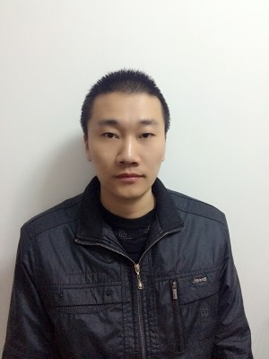
birthday | 1988 12 13 | country | China
diploma | bachelor | major | English
mai | nuxyah@163.com
phone | +86 18337908625
resume | 2006-2010 majored English in henan university of science and technology ,got a bachelor diploma in linguistics.  2010-2013 taught English at elementary school in my hometown.  2013-2015 worked as a Russian-Chinese interpreter for border trading in a Chinese border city on Russia called Suifenhai.  2016-2017 worked as a English-Chinese interpreter for oil refinery in Saudi
other | I’m a native Chinese speaker with a sense in literature and rhetoric. I’m also well trained in English, although it’s not my first language but I listened a lot from movies and when I was in Saudi it’s my work language. I also learnt Russian when I was doing trading job with them, writing is a little bit difficult but I could perfect understand what they are talking about. I just love linguistics when I was learning English I found out so many words were came from the other side of the strait, so French was what I picked up by the way of English.  I’m also a enthusiast in science and technology, silicon valley is my idol, read a lot about them, consider it to be my future with focus on computer and biology, hopefully someday could make a live on them, but right now I just want to be a freelancer in any scope related to language translation.

