Curriculum Vitae |  |  | 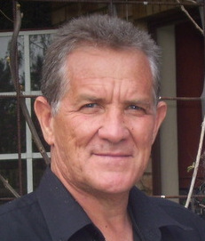
1 | Name and Surname | Frederik Johannes Harmse
2 | Persal Number | 13898345
3 | SACE Number | 101565
4 | ID Number | 5504125014080
5 | Gender | Male
6 | Race | White
7 | Citizenship | South African
8 | Criminal Record | None
9 | Current Employment | Selborne Primary School Vanderbijlpark
10 | Years Teaching Experience | Post level 1 : 17 Years  Head of Department: 18 Years
11 | Subjects Taught | English, Afrikaans, Social Science, Physical Education, Life Orientation
12 | Training and Qualifications | Goudstad College of Education: Senior Primary Diploma  Goudstad College of Education: Four Year Qualification in Physical Education
 |  | Teachers College for Further Education: Diploma in Youth Preparedness. (Life Orientation)
13 | Extra Mural skills | Extensive experience of coaching various sports on National and International level.
14 | Experience outside Education | Owner and Manager of several Health Centres.  Specialised in Training Programmes for Sport
15 | Additional Educational Skills | Developed effective Reading Programmes.  Developed effective Disciplinary Systems.  Ability to teach Plays and Dramas. (Fundraising)  Strong motivational speaker.
17 | Computer Skills | Good command of:-  - Microsoft Word  - Microsoft Exel  - Internet Research
18 | Telephone Work | 016 422 1772
19 | Cell Phones | 0742147773 / 071 0109821
20 | Marital Status | Married since 1981
21 | E-mail | harmse.frik@gmail.com
22 | References | - Mr Dewald Botha - 0834090289 – Current Principal  - Mr Philip de Wet - 0827809075 – Previous Principal  - Mrs Phylis Monametsi - 0725103623 – Previous Principal  - Professor Tielman Slabbert – 0825660800 – Head of Brunstad Christian Church StephanoPark.  - Mr. Deon Schlecter Oospark - ‎082 556 0454 Principal

