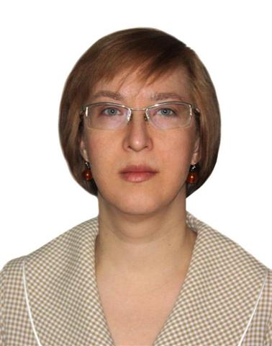

CV of a translator

Name | Elena Kolesnikova
Date of birth | 7 September 1970
Residence | RUSSIAN FEDERATION
Home address | Avrora Street 5/7, Apt. 49, UFA, 450092, RUSSIAN FEDERATION
Native language | Russian
Education

1987 – 1992 | Ufa State Aviation Technical University  (System Engineer)
2001 – 2003 | Ufa Center of Foreign Languages (English language)
2010 - 2012 | Ufa Language Academia (Japanese language)
Work experience

1993 - 1996 | Computer class supervising engineer (Ufa Technical University)
1997 | Secretary at the office of Department Head
from 2000 till present time | Freelance translator (by Internet from 2006)
Type of translation | Written translation
Primary language pair | From English into Russian
Secondary language pair | From Russian into English
Additional language pair | From Japanese into Russian
Words per day | 2,500
Subjects of translation:

Machinery | User manuals for machines and equipment
Chemistry | Material Safety Data Sheets for chemicals
Medicine and Pharmacology | Case histories, results of medical examinations and lab tests, pharmaceutical documentation, clinical tests protocols, articles from medical journals
Advertisement | Advertisement texts for cosmetics, perfume, homecare products etc.
Other possible subjects | News, History, Science, Tourism, personal documents
Undesirable subjects | Economy, Business, Law, Computers and IT, Electronic, Cars
Equipment | Computer, printer, scanner, Internet
Software | MS Word, Excel, Adobe Reader
Personal characteristics | Reliability, grammatical correctness, erudition
Some translation agencies I work for | Doka (Russia), Skrivanek (Latvia), Swan Innovation (India) etc.
Mobile phone | +7 917 4459957
E-mail | winhild@rambler.ru  anthyh9@gmail.com

I am always ready to do a test translation to prove my skill.

