Mrs Chiho Nakamura
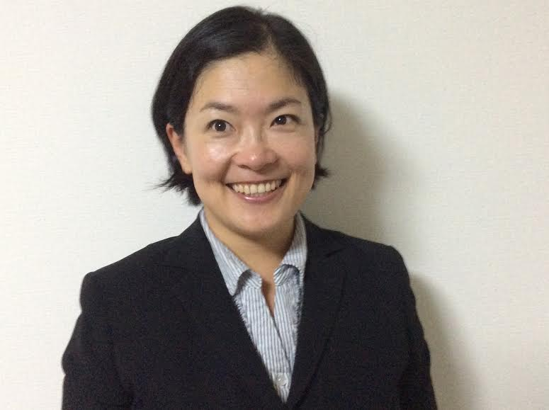
60 Beach Road, Carlyon Bay, St. Austell, Cornwall. PL25 3PJ 362-0032. Ageo-shi. Hinode 1-3-18. Twins C1. Saitama. Japan Tel: (Japan) 048 628 0308 nakachiho1230@hotmail.com Date of birth: 30 December 1972
Language pair: English (source) to Japanese (target)
- Within my current position, working within procurement for UD Trucks Japan, a subsidiary of Volvo, I have added value to the business by drawing on my communication skills to profitably negotiate with a diverse range of international suppliers. This role also requires accurate translation from English to Japanese.
- Over the past few years I have successfully completed a variety of different translation projects, using my primary language pair. I have translated for a diverse background of clients encompassing the following areas; marketing and sales, business and commerce, and manufacturing and engineering.
- During employment with Asda’s Home Shopping department I have used my interpersonal skills to work effectively as a member of a team. I have also provided outstanding customer service whilst developing my understanding of British business language and culture.
- Whilst employed by Asics as a Sales Representative from 1997 to 2004 I consistently achieved or exceeded annual sales targets. These targets grew from £400,000 at the beginning of this period to £650,000 by the end. This growth of revenue was achieved whilst maintain profit margins of 30%
- Directly managed Asics Corporation flagship store in Tokyo. This role incorporated many responsibilities including; deciding on a suitable location, merchandising and marketing, developing appropriate product lines, shop floor display, recruiting and training staff in customer service and product knowledge
- Nurtured and developed business relationships with retail and wholesale customers. These were mainly department stores and shops in the Greater Tokyo area. (approximately 20) My strong communication skills and knowledge and understanding of the industry and markets enabled me to anticipate,

MAJOR ACHIEVEMENTS:
I am an experienced, bi-lingual, Economics Graduate with a proven track-record in sales and marketing. In the last few years I have been focusing on using my outstanding, written, English and Japanese skills to complete freelance translation projects. My excellent language, interpersonal and communication skills, holistic business knowledge and determination to surpass client expectations are key strengths. From 2006 to 2013 I lived in the UK, during this time I increased my understanding of western business practices, language and culture through my role within home shopping with Asda. Within my current position in product procurement with Volvo (Japan) I have further developed my communication skills, effectively negotiating with a diverse range of international suppliers. My position with Volvo has also required me to translate documents from English to Japanese. I am seeking appropriate freelance translation projects, my specialist areas include; marketing and sales, engineering and business and commerce. I am confident in my ability to translate with speed, fluency and accuracy and would have no problem translating outside my areas of specialism.

PROFILE:
REFERENCES:
Volvo. UD Trucks Japan. Saitama, Japan Procurement Consultant 2014 (Feb) to date
Asda. Home Shopping dept. Saint Austell, UK Customer Service 2008 to 2013 (Dec)
Asics Corporation. Tokyo, Japan Sales Representative 1997 to 2004
Hakuba Ski-School Nagano, Japan Ski Instructor 1993 to 1996
EMPLOYMENT HISTORY:
- Asics: Provided advice and guidance to my retail and wholesale customers about product information, shop floor displays and visual merchandising. I identified staff training needs and requirements and provided this
- Asics: Developed a sophisticated understanding of the business and industry, through market research, field research and industry data analysis and used this understanding to, build strategies and business plans, inform merchandising decisions and develop new product ranges. This knowledge enabled accurate long term forecasts of business trends and patterns.
- Increased market penetration of the Asics brand, in particular Jane River (ladies outdoor wear) product lines by using knowledge of markets and industry to target appropriate new customers. My interpersonal and communication skills, combined with an emphasis on first-class customer service ensured the development of productive new business relationships.

Ms. Miki Chou. (current employer) Human Resource Manager. UD Trucks Japan Saitama-Ken Ageo-shi 1-1 362-8523. Japan. miki.chou@volvo,com Japan +81-48-781-2342
B.A. Economics Gained from Daito Bunka University (Japan) 1992 to 1996
Asics Corporation In-house (sales focused) professional development program 1997 to 2004
Industrial & Commercial book keeping Japanese Business Association Grade 1 & 2 1996
Secretarial & Administrative skills Test Japanese Business Association Grade 1 & 2 1996
International Ski Association Instructor: Gold Certificate 1995
High School Graduate Graduated from Ageo-Minami High School 1991 Saitama – Ken. Japan.
Computer Skills High-level of PC literacy. Confident using different software: Word processors / spread sheets / presentation software. OS Windows & Mac OS CAT: SDL Trados / Wordfast

QUALIFICATIONS & SKILLS:

