THE RESUME OF
No. 366 Tshepo Street, Tweefontein F
Somarobogo, 1023, Mpumalanga
+27 83 341 5975
bbskosana@gmail.com
Linked-In
Bongane B. SKOSANA
Freelance Translator & Language Practitioner

Professional Summary
A multi-skilled, reliable & talented translator with a proven ability to translate written documents from a source language to a target language. Qualified Zulu/Ndebele Language Practitioner with excellent communication. Hard-working, friendly and very much a team player. Seeking a professional business environment, and would like to find a challenging position to meet my competences, capabilities, skills, education and experience.

Academic Information
Translation Technique Course [TTC]
Watchtower Society SOUTH AFRICA
In-service Training on Language & Correspondence Communication
Continuous Since: 2010

Dynamic Witting Skills
Online Course
Author in Vernacular Language
Continuous Since: 2011

Graphic and Advertising Design
Short Course Certificate
INTEC College
Graduated: 2013

Service History
March 2010 – Present: Translator and language based activities
English to Ndebele/English to Zulu
WATCHTOWER SOCIETY SOUTH AFRICA
November 2010 – Present: Freelance Translator/Interpreter for various Translation Agencies
Responsibilities:
- Write Zulu/Ndebele subtitles for English language programs (news, films and chat shows)
- Provide translation services for any documents, research or administration
- Liaise with English and Zulu/Ndebele speaking staff, stakeholders and the public
Achievements:
- 2011 Translated Multilingual Dictionary [Aeronautical Dictionary]
- Translated various publications including videos and audio scripts

Other Skills/Qualifications
- Member of the African Linguist Network (ALN)
- Proficiency with MS Office – Word, Excel, PowerPoint

References
Translator/Vendor Manager  Koketso Rakolota  Polokwane, South Africa  (+27)79 019 2847  dominant45@hotmail.com | Quality Translations  Owner & Producer  Leonard Moloi  (+27)82 968 8200  qualitytranslations@tiscali.co.za

Translator  Mlungisi Gasa  Mpumalanga, South Africa  (+27)83 494 4810  mlungisigasa@gmail.com | Mosekola Translation Services  Abi & Pheledi Mathibela  South Africa  (+27)82 057 3175  info@mosekola.co.za

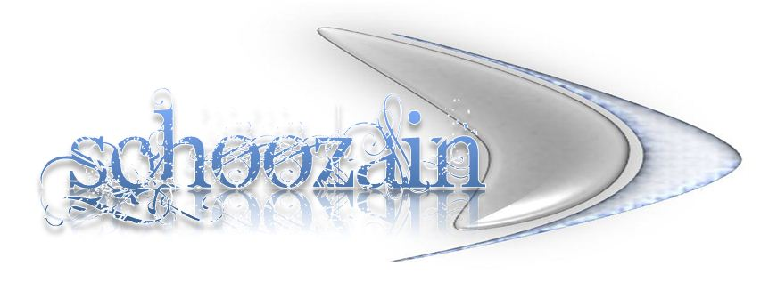

For more info please visit my Linked-In profile.

