C.V.
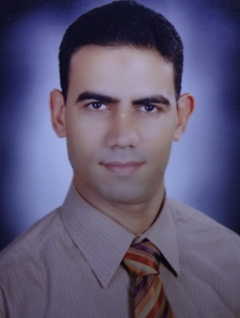
Name: Ahmad Mohammad Ali Al-Rowainy
D.O.B: 7th, May, 1974
Education:
- B.Sc. In Science Education, Physics and Chemistry Dept. Faculty of Education, Alexandria University, 1995.
- Special Diploma in Methodology and Science Curricula, Faculty of Education, Alexandria University, 1997.
Job History
- Science and Physics teacher, from 1995 to 2001.
- Bilingual (Science and Physics) teacher, from 2002 to 2012.
- Translator (General, Educational, Scientific) from 2007 up till now
Interests:
- Translating scientific and thought content
- Simplifying scientific knowledge (science literacy for all)
- Supporting Higher-Order Thinking skills for young learners
Additional Courses, training and skills
- Teacher Preparation Course, Kings’ College , London university, 2002.
- ICDL, 2003
- IELTS, 2008
- IC3 computer skills, 2009
Previous Works
- Unpublished translations for educational research purposes (Science)
- More than 7 Books published to the moment, and 4 more books under press (all are for professional development for teachers and administrators) for The Educational Book House, a publisher in Saudi Arabia.
See images of books of my translation in the next page.
Contact Details
E-mail: rowainy@yahoo.com
Mob; 00966548161203
Address:
Saudi Arabia
Eastern Province
Dammam, 31422
P.O.Box: 5162
The Educational Book House

