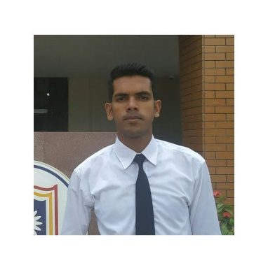
Abdur Rahman
Freelance Translator's
Email: a.rahman.ru1@gmail.com
Facebook: www.facebook.com/a.r.sompad
Mobile: +8801633051718
Objectives
A multi-skilled, reliable & talented translator with a proven ability to translate written documents from English to Bangla (Bengali) and vice versa. A quick learner who can absorb new ideas & can communicate clearly & effectively with people from all social & professional backgrounds. Flexible in the ability to adapt to challenges.
Would like to work as a translator or interpreter for a successful and ambitious company that offers great opportunities for career development and progression.
Work Experience
- Translator at Pakur limited (a registered Bangladeshi language company) Since April 2018.
- Working as a Translator for English to Bengali language pair at TWB(Translation without Border) since July 2018.
- Online Volunteer (Translator) at UN Volunteers , Since January 2018.
- Working as a Translator for English to Bengali language pair at Local agency since January 2018
- Associate Member UNYSAB , Rajshahi Divison.
- Member at Rajshahi University Engineering Club,Rajshahi.
Language Pairs & Translation Capacity
English – Bengali & Bengali – English
Normal: 2000 words per day
Burst mode: 3500 words per day
Areas of work & Interested to Work
Specialized in: Building & Construction, Oil & Gas, Heavy Industry, Legal, Military, Education, Health, Business (contracts, annual reports, SHE etc), Immigration/Police, Arts & Culture, Automotive, etc.
Computers(general)/IT/Systems/Networks/Telecom(munications)/eCommerce/Hardware/SoftwareManagement/Human Resources/Advertising/Public Relations • Business/Commerce (general)/Contracts/Finance (general)/Investment • Law/Taxation & Customs/Certificates, Diplomas, Licenses, CVs • Architecture/Construction • Medical (general)/Biology (-tech,chem,micro)/Pharmaceuticals/Cardiology/Psychology •
Journalism/Media/Multimedia • Paper/Paper Manufacturing • Poetry & Literature/Linguistics
Skill
Expert in CAT tools and other translation related software such as SDL Trados Studio, memoQ, Adobe Acrobat Pro, Adobe Photoshop, etc. Able to fluently speak English, Bengali. • Excellent English speaking and writing skills. • Excellent communication and social skills. • Skilled in WordPress publishing platform for website posting/translation• Able to work with tight deadlines. • Highly skilled in Microsoft Word, Excel, PowerPoint and Outlook. Willing to travel and able to work under pressure.
Academic Qualification & Certificate
- B.Sc. Engineering
Department Of Materials Science & Engineering .
Result: YGPA 3.65 out of 4.
University Of Rajshahi ,Rajshahi.
- Certificate course in English Language.
Institute Of English and Other Language .
University Of Rajshahi,Rajshahi.
PROFESSIONAL REFERENCES
- Pakur Limited : Hamid, Project Manager, Pakur Ltd.
pm2@pakur.net Mobile: +8801742-985005
- Ariful Muntasir : arifulmuntasir1@gmail.com
Mobile:+8801701060430
- Translation Without Border : Ambraluna, Community Management Intern,
ambraluna@translatorswithoutborders.org

Contacts
Md Abdur Rahman
Nationality: Bangladeshi
Address: Room no 301,Nur Mahal,Binodpur,Rajshahi,Bangladesh.
Email:a.rahman.ru1@gmail.com
Mobile:+8801633051718
Skype:
Rate & Payment
I accept payments in Euro or US dollars or BD Taka by Bangladeshi Local Bank like as Agroni Bank ,Exim Bank. Translation rate per source word (basic): 0.03Euro. Minimum Charge: .01Euro. Hourly rate (proofreading): 10 Euro . Minimum charge: 8 Euro . The rates are negotiable.

