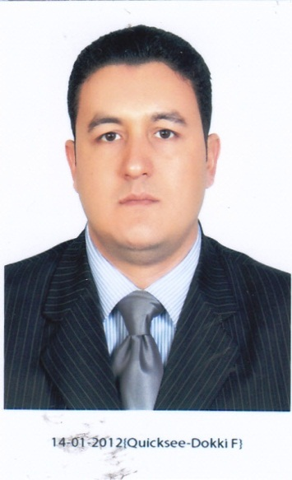

Personal Data:

Name: Abdulmonem Madbuoly Saad
Date of Birth: 1977/06/15
Marital Status: Married.
Military Service: Exempted.
Mobile: 00201001274869 -01118264481
Address:23 Mohamed El-Kashlan-Madinet Amer-Boulack Eldakror-Giza, Egypt.
Nationality: Egyptian

E-mail: monemmadboli@yahoo.com

Education:

- Bachelor of of archeology 1999 Faculty of archeology Cairo University
- Post Graduate Diploma 2004 in Tourism –Guidance section
Computer skills:

Operating Systems: Windows XP –windows 7
Applications: Microsoft office2007/2010 (Word- Excel, Access, and PowerPoint)
Work and Training Experience:

Working as tour coordinator in NTS EGYPT 1999- 2004

Working as a freelancer tour guide 2005-2012

Workings as freelancer translator 2012-2015
Languages Skills:
- Arabic - Mother Language.
- English - (Written -Reading – Conversation) excellent
- Italian -(Written -Reading – Conversation) excellent
- Chinese -(Written -Reading – Conversation) very good

Personal Skills:

- Self Motivated and ability to work with team work.
- Eager to learn.
- Multi tasks person.
- Able to work with moderate supervision.
- Adaptable and flexible.
- Hobbies: swimming-internet-reading

