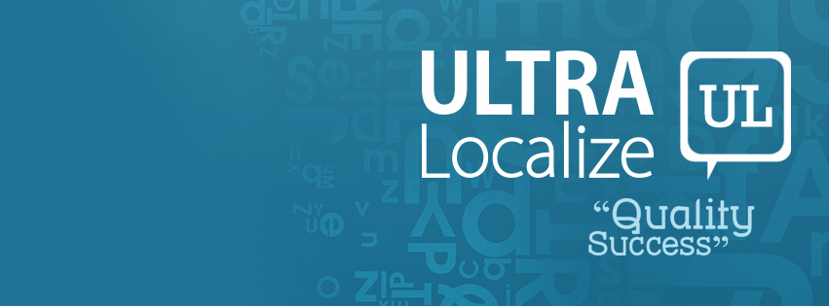

Index
Who We Are?.…………………………………………………………………………….………2
Mission, Vision, Values……………………………...……...……………………………………3
What We Do?……………………………………………..………………………………….……4
Why Us………………………………………………………………………...………………….5
Our Clients………………………………………………………………………………...………7 Contacts…………………………………………………………………………………………...8
Ultra Localize Profile

Who We Are?

Ultra Localize is a professional company for linguistic services. Our services are focused mainly on localization, translation and desktop publishing (DTP). Ultra Localize has a vast experience in providing top quality linguistic services. Our expertise varies to cover different fields like software, accounting, marketing, engineering, financial, legal, medical, international organizations, social work and much more.

Ultra Localize is specialized in Arabic language, as we have a staff of highly qualified linguists and DTP specialists who are very well experienced and enjoy a deep understanding of the Arabic language and aspects of perception in the Middle East region in both North Africa and the Arab Gulf.

Arabic Translation Services

Our main languages are English, German and Arabic; in addition to other languages. We have many native linguists who have extensive experience in different fields, in order to make sure each project is assigned to the linguist(s) with the perfect matching experience and skills.

With our professional Arabic translation services, you have access to more than 450 million speakers, more than 25 countries mostly in the MENA region, 200 million internet users, and approximate 8 trillion GDP at purchasing power parity (6% of the world). This huge audience represents an immense market for all industries and service providers from around the world. In addition to our linguistic proficiency, we also master the diverse local cultures of the Arabic speaking countries, from ocean to Gulf, in order to adapt your materials to each targeted local culture and give them the original twist and authentic sense.

Our scope of processing goes far beyond ordinary translation to a wider vision of cultural consultations in order to make sure you don’t only get your materials translated perfectly, but also achieve success in your mission and reach your goals.

We are more than just a language service provider; we are your success partners!

Mission

To provide a comprehensive package of high-quality linguistic services that are based on cultural adaptation and consultations.

Vision

To be globally known as a partner for creating a genuine linguistic product that perfectly fits the target audience.

Values

The company holds four core values that define the character of Ultra Localize and shape its internal culture as well as external relationships. These values are:

  - Customer Satisfaction: We are committed to satisfying our customers through high quality, on-time delivery and low cost.

  - Agility: We are committed to agility through flexibility & activeness.

  - Professionalism: We are committed to professionalism through high standards of behavior & perfectness.

  - Credibility: We are committed to credibility through our challenging, skilled & talented staff.

What We Do?

Localization & Translation

Many people mix between translation & localization, but actually, both activities differ much from each other.

Localization is the process of culturally adapting text and content to specific target audience. During translation, several adjustments are made to cope with units of measurement conversions, currencies, use of decimal separators, punctuation, hour display formats, etc.

In brief, Localization makes the world smaller, brings people much closer and understand each other not only in language but culturally!

At Ultra Localize, our staff makes the process go smoothly & much easier as they really have long deep experience with all localization processes and tools.

Desktop Publishing

Introducing a new version of your product in another language does not only require a linguistic process, it rather requires a DTP process in order to adapt the content to the specifications of the target language. The DTP process includes adaptation of many elements like text direction, numbering, font size, etc. Therefore, such process requires a huge amount of attention, concentration and accuracy to catch the smallest details. In doing so, Ultra Localize specialized and skillful staff always uses the most famous, and up-to-date DTP applications to put the final touch on the content in order to introduce your product in the best way possible.

Why Us

Flexible Availability, Expandable Capacity and Ability to Meet Tight Deadlines

    - Time is money; we all know that. Therefore, we have a complete understanding of the value of time for our clients and always make sure to satisfy the needs of our clients within their preset timeframe. We also make ourselves available to help our clients with urgent tasks in day-offs and tight times. Moreover, we have an expandable capacity that enables us to handle huge-volume projects that may exceed millions of words in a limited period.

Quality Management (Workflow & Cycle)

    - Quality = Success, the easiest equation on planet Earth! Based on our full awareness of the importance of quality in translation, we have built a solid quality management system that guarantees unrivalled quality. Our workflow cycle could be summarized in the following points:
      - Project Analysis
      - Terminology Management
      - Translation
      - Revision
      - Editing and Proofreading 6- Query Management
7- Implementing client feedback 8- Delivering final version

Comprehensive Package of Services, once place for all your needs (Translation, DTP, Localization Engineering)

    - When handling your written content, you have additional needs beside translation, as desktop publishing and even localization engineering in case of software translation. Having to handle each of these needs with a different supplier would be very costly in terms of time, effort and most importantly money! Therefore, we provide you with all such services in one place that perfectly understands what you exactly need.

Specialized Expertise

    - From marketing to legal, and from education to politics, each domain has its own requirements in linguistic production. Based on this fact, we tend to allocate the best experts in each field in order to guarantee best quality possible that is built on deep understanding. This is embodied in combining top human talents with best-matching specialized references.

Cultural Awareness

    - Promoting your product or service and delivering your message to the target audience is a complicated process that goes far beyond translation. You need to speak to people in their own way. One language may be spoken in multiple regions; each has its own culture and mentality. What could be acceptable in one country may be unacceptable in another. Therefore, we take care of the specific locales of the target audience to make sure your message is delivered in the best way possible. It’s not only what you say, but also how you say it!

Content Adaptation (Creating a Genuine Script)

    - We do not provide translation as a mere linguistic process; transferring words from one language to another. We handle the process with a wider perspective as an adaptation of the content in order to create a genuine script that the readers perceive as if it was originally created for them. It’s a very challenging target to perfectly balance between keeping the core of the original content and creating a stylish output, but we do love challenges!

Unique Identity, who likes to be alike?

    - You don’t want your product or service to be presented in a regular way, or you would be lost among thousands of competitors! Uniqueness in one of the major elements of success these days, and that is why we do our best to give your message a unique identity and make your product shine bright. Using special terminology and style for each product or line of items give it always liveliness and uniqueness to stand out from the rest, which is exactly what you need.

Our Clients

We are proud to have acquired the trust of many prestigious clients around the world through our dedicated service and outstanding quality. Our list of clients include major companies in different sectors like Discovery Education, Orascom Development Holding, Lufthansa Cargo, and Innovation First International.

Contacts

Address: 11 Ahmed Zaki st, Obour Buildings, Cairo, Egypt.
Landline: (+202) 24014277
Cell Phone: (+202) 01024900182
Email: contact@ultralocalize.com

Communications Manager
Ahmed Morad: ahmed.morad@ultralocalize.com
Website: www.ultralocalize.com

* We are available 7 days a week

