MEMORANDUM & ARTICLES OF
GLOBAL TRANSLATED NET, INC (GTN)

Global Translated Net, Inc(GTN) provides high quality human translations and transcription with certified and experienced native translators. We assure you the utmost accuracy possible. We have a great team of ethical and professional native translators (5000+ translators) for over 180 languages (http://www.globaltranslatednet.com/languages) from 32 countries. We have a keen eye for details and all your requirements are considered in all our language services. In my opinion, this is how you can be assured you are working with the best language translation provider for your organization. We look forward to exceeding your expectations and providing you with unmatched professional and granted translation services.
Translation Services:
1. All kind of Document Translation
2. All kind of Document Proofreading
3. Post-Editing
4. Transcription
5. Video Translation
6. DTP service
Delivery and Support
Each file done by our one of professional translator and two professional quality checker, no way for bad work (it’s including in your same translation budget) for 100% error free work and delivered in the requested format On-time. We do it in your budget because we just not want money, we want a trust-able relation for long term, we want our client full satisfaction, we want everyone love and respect with our honest and satisfied work. That’s why we have 2 professional proofreaders for every one translator translation checking. We offer support for your project for four months after the project is delivered and are happy to make changes if the client is not satisfied.
So what is included in the translation price?
1) Translation into the target language by a native speaker
2) Proofreading of the translated text
3) Text format according to customer requirements (Free DTP service)

Our team work ability:
1. Translation: 3000K-3550K Word/per month in each language.
2. Proofreading: 10000K-12000K Word/ per month in each language.
3. 20000-25000 minute audio or video transcription/ per month in each language.
4. 30000-40000 Pages formatting per month (File supported: MS word/PDF/Indesign/Photoshop/Illustrator.

Languages:

http://www.globaltranslatednet.com/languages

PROFESSIONAL PROJECT OVERSIGHT

Our project managers guide each project—from initial translation, through editing and formatting, to final review and delivery—paying close attention to both cost and schedule. They are well-versed in documentation for your industry and alert to any cultural issues that might arise.

THE HUMAN ELEMENT

We have fostered decades-long relationships with our translators and assign only native speakers with industry-specific experience to your project. You can rest assured the translator knows both the technical and linguistic nuances that could otherwise muddle your meaning.

CLIENTS THAT TRUST INTO OUR WORK
This is just a small list of our happy client.
- Alexandra Hospital
- Binatone
- Canon
- Apple
- Greenpeace
- Amazon
- MISUMI
- BBC
- NIKE
- Health Promotion Board
- Motorola
- Nestle
- Paraxel
- Porsche Asia Pacific
- Philips
- Raffles Hotel
- Rentokil
- Sanofi
- Singtel
- Suncorp
- Temasek
- TranslatedNet
- WorlSys

ISO 9001:2008 Certification – What It Means For Your Technical Translations

Global Translated Net, Inc. demonstrates our commitment to quality through our ISO 9001: 2008 certification. Our documented quality processes are certified by ISOQAR, a global ISO certification firm, and are audited annually. ISO 2001:2008 certification is your assurance that our quality-management process meets stringent standards, and that we follow that process consistently and effectively. In short, this is your guarantee that your message is delivered on time and communicates as intended in all of your target languages.

OUR SUPPORTED PAYMENT METHODS
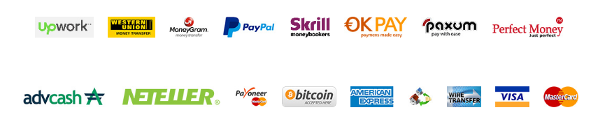
Meet us at our offices project manager listed below or just drop us few lines about your inquires: http://www.globaltranslatednet.com/contact .
We are probably doing some translation work at the moment
but will do our best to come back to you – right away.

