FAKIHA MUSTHAFA PP
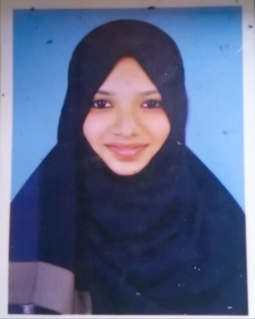

Mobile:+919961486563
Email:fakirash24@gmail.com
Current location:Feroke, Calicut
Career Objective:Seeking the role of Teacher where I would be given an opportunity to utilize the theoretical skills, sense of responsibility and efficiency to approve my qualification.

Educational Profile
2016-2019
- Bachelor of Arts in English from Al Farook Educational Centre, Calicut, Kerala.
- Completed with an aggregate of 78.8%
2014-2016
- Grade 12 from Markaz English Medium Senior Secondary School, Calicut, Kerala.
- Completed with an aggregate of 80"%
2013-2014
- Grade 10 from International Indian School Dammam, Saudi Arabia.
- Completed with an aggregate of 76%

Academic Project
- Project Details
Title: Female Identity In Afganistan Against Religious Oppression In A Thousand Splendid Suns.

Extra-Curricular Activities
- Participated in school and college level competitions in English poem vercification and story writing and was selected for district and state level competitions, where i have achieved first and second places.
- Participated in literary fest exhibition.
- Editor of the college magazine "Infinity".

Key skills and Knowledge areas
- Strong team collaboration skills. Work closely with seniors and trainers to achieve literary goals.
- Excellent communication and interpersonal skills.
- Ability to work independently.
- Hardworking, multitasking and dedicated.

Personal Details
DATE OF BIRTH :29th June 1998
NATIONALITY : Indian
MARITAL STATUS : Married
LANGUAGES KNOWN : English, Hindi, Malayalam and Arabic (basic)

