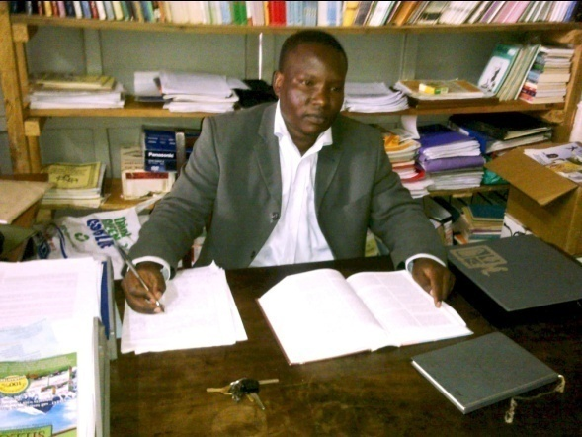
RICHARD MAISIBA
AUTHOR

AUTHOR’S bio
Richard is a dedicated writer, a refined pianist, and a proficient linguist. He has published one book, Cities of Refuge (2013); I have vast experience in transcription, translation, and New Writing. As a ghostwriter, I have featured in several publications including posts on Hubpages.com.
His mission is creating finer items of civilization. He is willing to cooperate with individuals and institutions to achieve personal and corporate growth.

SKILLS
- WordPress
- SEO
- Microsoft Office
- Broadcast and Print Media
EXPERTISE
- Creative Writing
- Education/Pedagogy
- Nutrition/Geography/Government
- Advertising and Public Relations
- Poetry
EDUCATION
1998-2004 Maseno University B.Ed. (Arts)
2016-2019 Mount Kenya University
B. Arts, Journalism
WORK EXPERIENCE
2018-2022 Managing Editor
Dream Master, Kenya
2013-2018 Transcriber
Republic Writers Bureau
2006-2013 Transcriber and Interpreter English to Swahili
Praise Celebration Center, Eldoret

REFERENCES
- Bishop Dr. George Gichana
Deliverance Church, Eldoret,
Kenya.
+25472291926
- Rev. Job Wanyama
Teen Challenge, Kenya
+254725930993

CONTACT
Website: African’s Finest Writer
Email: richardmaisiba69@gmail.com
LinkedIn: Richard Maisiba
Facebook: Richard Maisiba
Twitter: @maisiba_richard
Telephone: +254741711309

“As within; so without.”

