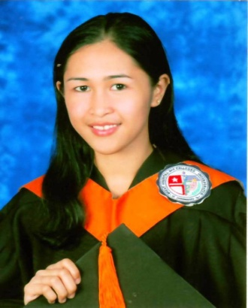
QUEENIE LYND JONDANERO MENDIJA
Sto. Niño Triplett, Zamboanga City
Mobile no. 0905-9230255
E-mail add: queenie88_1991@yahoo.com

CAREER OBJECTIVES

To obtain a position in the company where I can use my knowledge and enhance my skills in a dynamic and stable workplace, and give a high quality service to the customers.

EDUCATIONAL BACKGROUND

College Bachelor of Science in Nursing
Brent Hospital and Colleges Incorporated
R.T Lim Boulevard, Zamboanga City
2007-2011

Secondary Julian Soriano Memorial Comprehensive High School
Poblacion, Siocon, Zamboanga del Norte
2003-2007

Primary Siocon Central School
Poblacion, Siocon, Zamboanga del Norte
1997-2003

AWARDS & ACHIEVEMENTS

High School: First honorable mention (March 2007)
Student Government Association Senator (2003-2007)
School Treasurer (s.y. 2007)
1st place School Essay Writing Contest
Campus Journalism, Regional Level
-4th place, News Writing Contest (2006)
Journalism Awardee (2007)

Elementary: First honorable mention (March 2003)
PERSONAL DATA

Date of Birth August 10, 1991
Age 20 years old
Place of Birth Siocon, Zamboanga del Norte
Gender Female
Civil Status Single
Height 5’1”
Weight 45 kilograms
Citizenship Filipino
Religion Roman Catholic
Language of Dialect Spoken English, Tagalog, Bisaya
Special Skills Computer Skills (encoding, researching)

CHARACTER REFERENCE

Edwin Cardenas
Chief Operating Officer, Rural Bank of Siocon
Guiwan, Zamboanga City
Mobile no. 0917-7224788

Nenita Bagaipo
DENR Employee
Siocon, Zamboang del Norte
Mobile no. 0916-5942961

Lea Ruth Gamboa
Registered Nurse, WMMC Zamboanga City
Mango Drive, Baliwasan, Zamboanga City
Mobile no. 0927-9115518

QUEENIE LYND J. MENDIJA
Applicant

