RESUME/CV
Personal Information
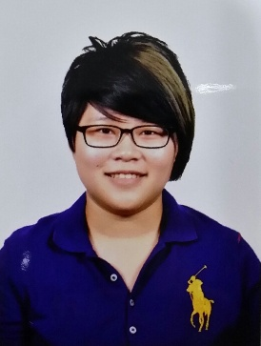
First Name : Pei Ni
Last Name : Lee
Age : 20
D.O.B : 12th August 1996
Email : peinilee00@gmail.com
Contact No : (+6) 012-3456248 / (+81) 90-1345-6248
Occupation : college student (from April 2016)
Personal features : eagerness to learn , willing to put effort into
work
Languages known : First language : Chinese
Second language : English , Japanese , Malay
Cantonese

EDUCATION
2016
- Fukuoka University
(Faculty of Humanities-Department of Culture)
2014-2015
- Institute Language Teikyo
(20months Japan Pre-U Preparatory Course)
Qualification : Japanese Language Proficiency Test(JLPT)N1
2009-2013
- SMJK Kwang Hua
Qualification : Sijil Pelajaran Malaysia(SPM)
(Malaysia certificate of education)

