PERSONAL INFORMATION | Mladen Andrei
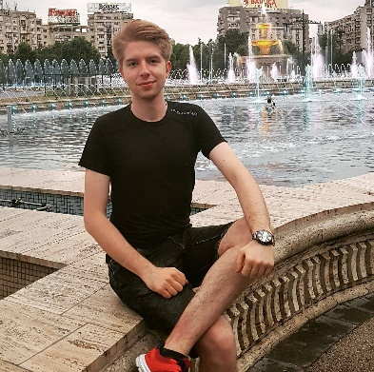
 | 0727.372.400
 | mladenandrei28@yahoo.com
 | Sex Male | Date of birth 23/02/1998 | Nationality Romanian

CERTIFICATIONS & SKILLS:
- “National Authorization as Translator and Interpreter” for French and English (issued by the Romanian Ministry of Justice);
- “National Certification as Translator in Legal Sciences” for French and English (issued by the Romanian Ministry of Culture).
- “Diplôme Accord de Langue Française », C1 level (equivalent of a DALF diploma).
- Experienced user of CAT tools (SDL Trados, MemoQ, XTM Cloud, WeLocalize, MemSource etc.).
- Experienced user of Office suite (word processor, spread sheet, presentation software)

EXPERIENCE AS A TRANSLATOR:
- 5 years’ experience in technical, medical, legal, and financial translations
Project examples:
- EN-RO, RO-EN & FR-RO, RO-FR translations of instruction manuals for furniture, solar panels, electrical appliances, IT & digital products etc.
- patient files translations (EN-FR & FR-EN),
- Translation of work contracts, enforcement procedure documents, purchase/sell/rental contracts, divorce procedures, from EN to RO & from FR to RO.

- 4 years’ experience in video games & software localization
Project examples:
- Localization of video games (MMORPG, action/shooter, racing, strategy etc.)
- Localization projects for PC software (SAP, Kaspersky etc.)

- 3 years’ experience in subtitle translation: video translation, SDH-creation, speaker identification, video transcribing, time-coding and video encoding.

EDUCATION AND TRAINING

2019 - 2021 “ European MA in Conference Interpreting (French-English) ”

2016 - 2019 University of Bucharest, Bachelor’s Degree in Foreign Languages and Literatures (French-English)

        - French Literature
        - French Linguistics
        - French Translations
        - English Literature
        - English Practical Course & English translations
        - English Linguistics
        - Internships in French/English

September 2012- June 2016 High school diploma
“Mihai Eminescu” National High School, Bucharest
General skills:
- Vast knowledge of Romanian culture & civilization.
- Solid knowledge of universal and national history.
- Skilled in modern psychology and other socio-humanistic sciences.
- Native fluency in French and English

Mother tongue(s) | Romanian
Other language(s) | UNDERSTANDING |  | SPEAKING |  | WRITING
 | Listening | Reading | Spoken interaction | Spoken production
French | C2 | C2 | C1 | C1 | C2
 | « Diplôme Accord de langue française » (niveau C1)
English | C2 | C2 | C2 | C2 | C2
Communication skills | - Fluent French and English communication skills, acquired during an Erasmus stage in Lyon, France (January 2018 - June 2018).

Digital competence | SELF-ASSESSMENT
 | Information processing | Communication | Content creation | Safety | Problem solving
 | Proficient user | Proficient user | Proficient user | Proficient user | Proficient user

Other skills | - Experience in subtitle translation (French to English, English to French), acquired through various projects in collaboration with ”Yiuno SDI”, Swiss Solutions” and “ZOO Digital”.  - Solid knowledge of English and French financial terminology, acquired thanks to a translation stage at the “Contradiction” accounting firm (September 2017 – December 2019).  - Followed a 5-year French literary translations stage (2017-2022), at the “Cercle nomade des traducteurs”, hosted by the University of Bucharest.  - Practical stage in consecutive and simultaneous interpreting (October 2019 – April 2021), coordinated by French and English-speaking interpreters from the European Commission.  - Teaching practice in both French and English, at the “Școala Centrală” and “Iulia Hașdeu” high schools in Bucharest (October 2018 – April 2019).

