Karen Cantin
Email: cantinkaren@gmail.com

Languages
-English -French -Spanish

Schooling
-Translation certificate at Université du Québec à Trois-Rivières (UQTR) 2023

-MCIS Interpreter Course 2023

-Translation certificate at Translators without Borders (TWB) 2022

-Certificate in Teaching English as a Foreign Language (TEFL) at the International
TEFL Academy Chicago 2015

-Languages Profile of Arts and Letters diploma at Cégep Limoilou 2012

Work Experiences
-English <> French Canadian freelance interpreter, remote
January 2024 to present

-Linguistic Quality Assurance (LQA), remote
January 2021 to present

-English <> French Canadian freelance translator, remote
June 2021 to present

-English to French Canadian translator, non-profit organization, remote June 2021 to June 2022

-Teacher, Commission Scolaire de Portneuf, Canada
March 2021 to December 2023

-Customer Service Chat and Email, ITS Management, Australia
January 2020 to April 2020

-Customer Service in restaurant/café/bar, Fairmont hotel, Mont-Tremblant, Canada
May 2018 to May 2019

-Fashion Model, Montage agency, worldwide
2012 to 2019

Volunteering Kids Help Phone, since April 2022
Typing speed 73 WPM
Computer tools Trados Studio 2021, MemoQ, Antidote
Life experience Army Cadet League of Canada (2004 to 2010) Qualities Professional, fast learner, accurate, focused

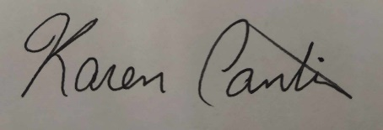
Karen Cantin

